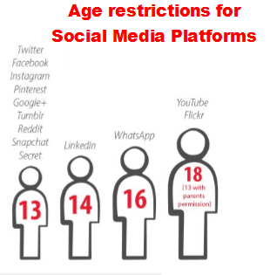
Online Gaming

It has recently come to our attention that an increasing number of pupils in school have been getting into arguments while playing online games such as Roblox. When situations like this take place we often see this manifest itself throughout the school day. This in turn has an impact on their education.

Social interaction amongst players is the most common risk player’s face. This is done by wandering around the online world and stopping to talk with other players within an unmoderated chat feature.

There is little control over the types of people or age limits of those playing the game. Despite the fact that strict chat filters can be activated - blocking inappropriate words and phrases - children are still open to be targeted by online predators.

Internet safety experts say that children should only play Roblox with the chat feature turned off.

This can be done by clicking the gear icon and going into account settings > privacy.

Children under 12 simply do not have the maturity to deal with the complex social interactions online, even with their classmates. They will always encounter problems, react without thinking or try and push things to the limit. Even if a conflict has been resolved with a friend, this will not stop it happening again.

We strongly suggest that the only way to keep them safe is to consider whether the game they are playing, and the things they are doing on it, are appropriate

