
Staying Safe Online

We have recently been alerted to a video game called ‘Poppy Playtime’ that is being described as an “introduction to horror”. The game and associated material are becoming popular on YouTube, Roblox, and other platforms used by young children.
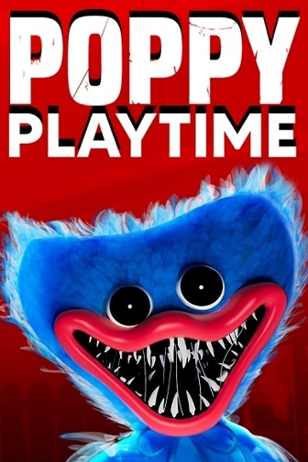
Poppy Playtime features frightening images and themes that are paired with child- friendly items. This may be especially upsetting to children who have not yet developed the resilience to deal with disturbing content. One character that appears in the game is known as “Huggy Wuggy” – a cuddly toy with a very shocking appearance.
Children may not actually play the game but it is very popular with YouTubers who do play-throughs. It is also copied on Roblox and Minecraft.
What are the risks?
There are multiple risks that can arise from young children being exposed to frightening content before they are prepared.
Added anxiety and stress – Children and young people are still growing and learning. They may not be at a level of emotional maturity that would be able to process frightening content. Horror games could hamper that growth by creating unnecessary anxiety and stress.
New fears – The manipulation of child-friendly items into threatening characters exploits the sense of security a child has the right to feel around these things. They may suddenly be terrified of something that had never been a worry before.
Steps to take
Pay attention to what your children are doing and make sure they you are not just trusting YouTube Kids and other games like Roblox to filter everything. Unfortunately, things do slip through the cracks all too easily. Check their watch history and look out for any concerns.

